Phase 1: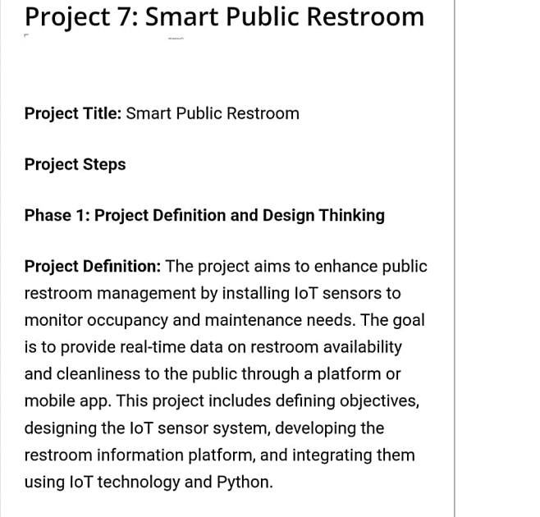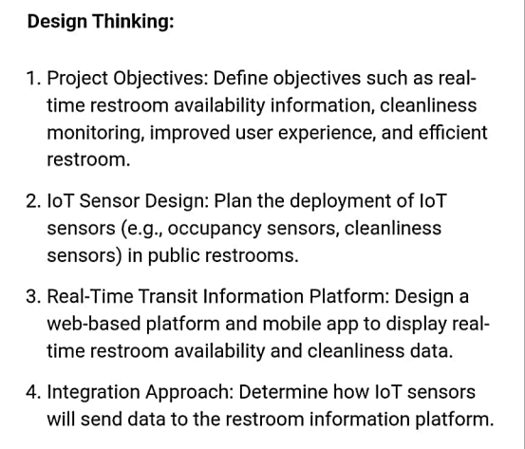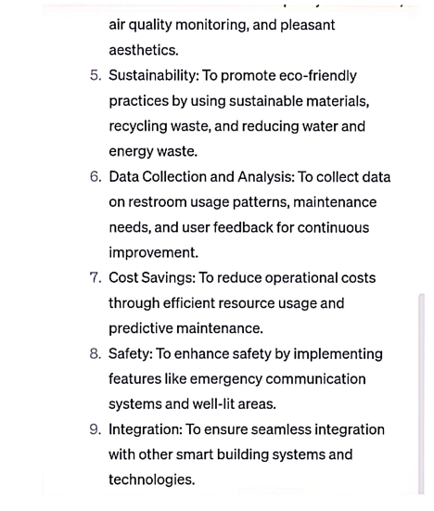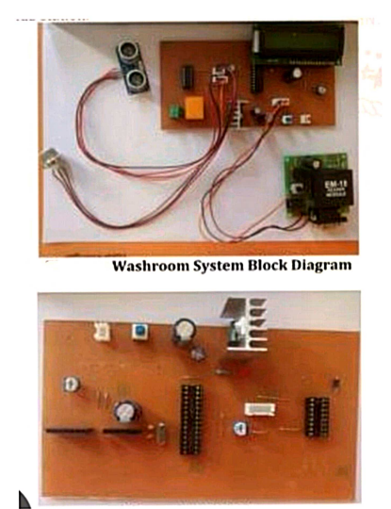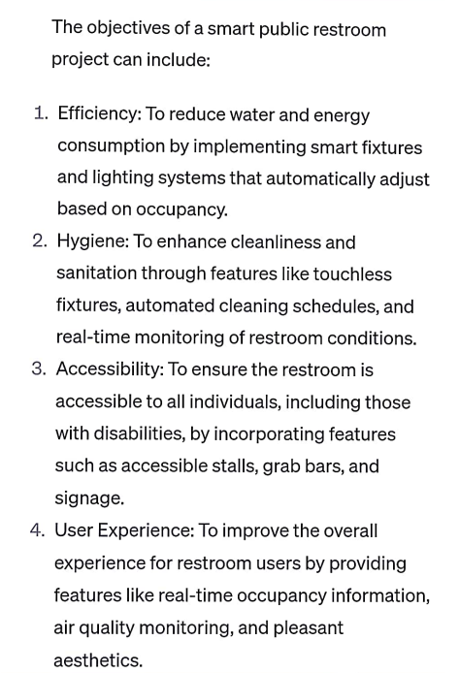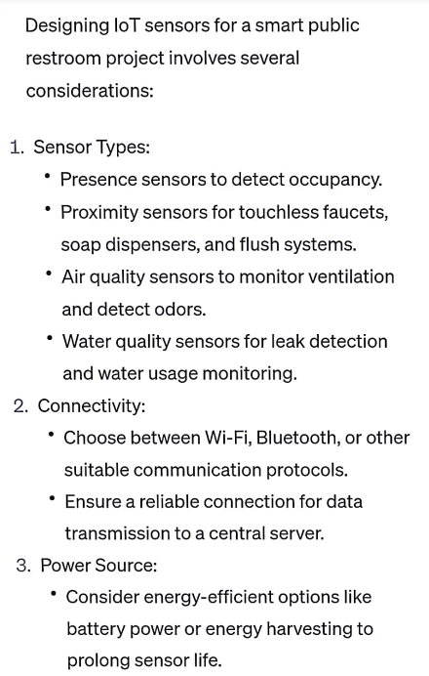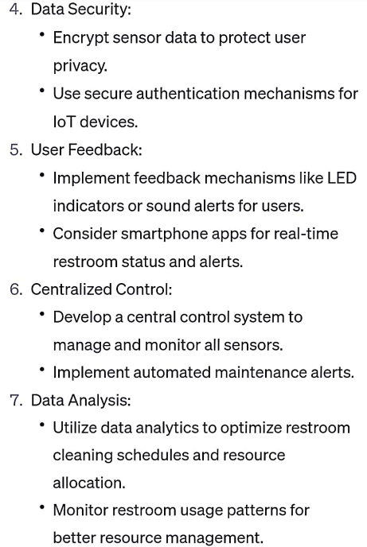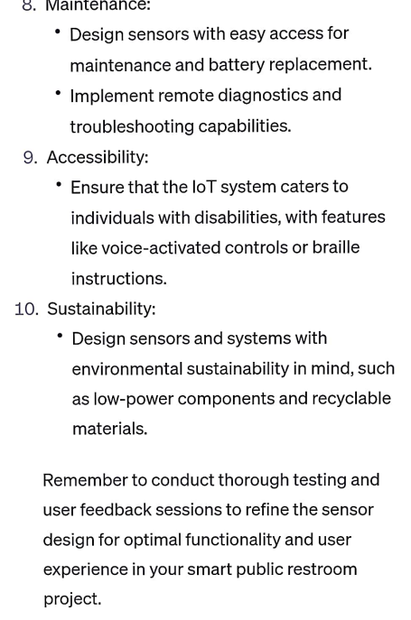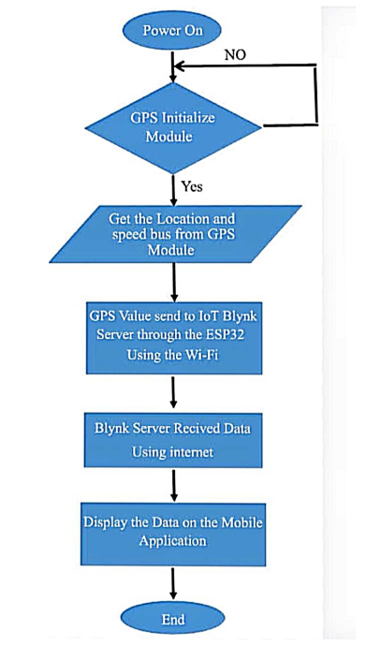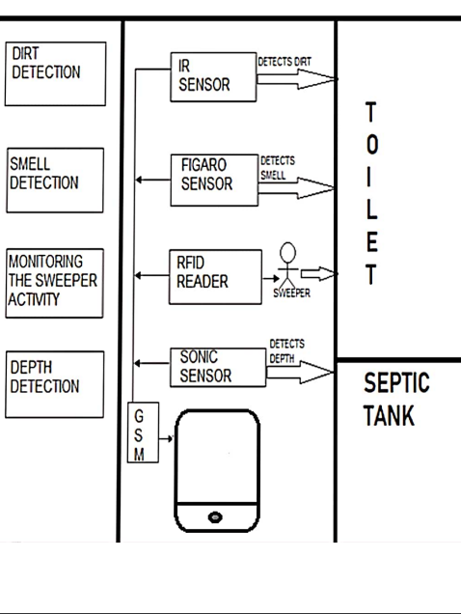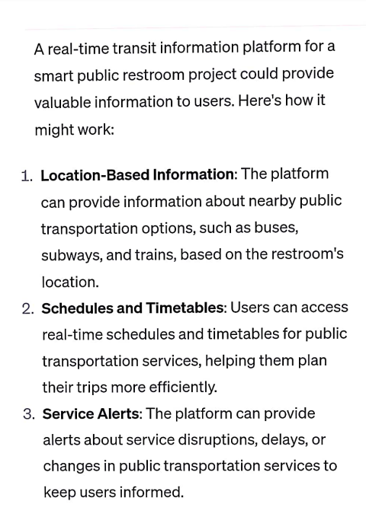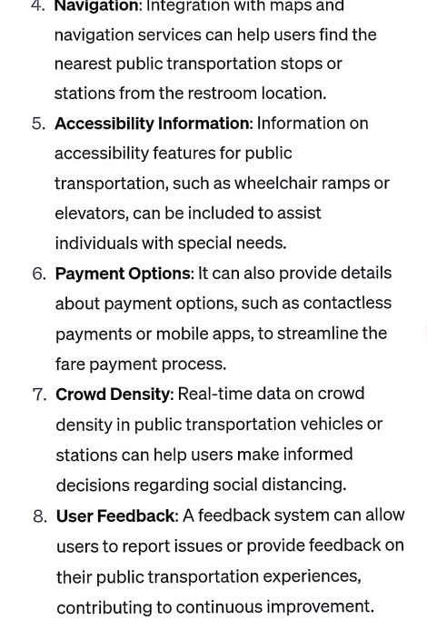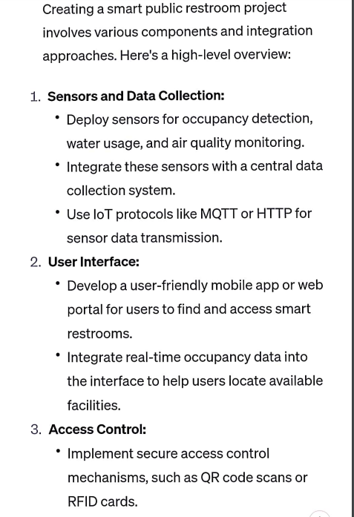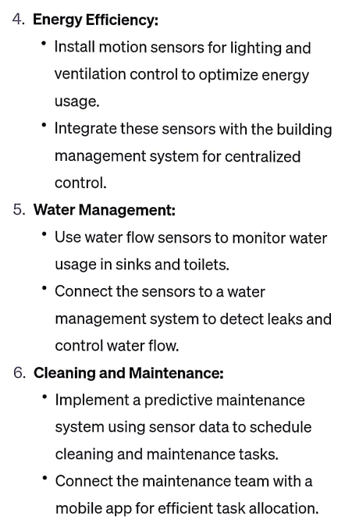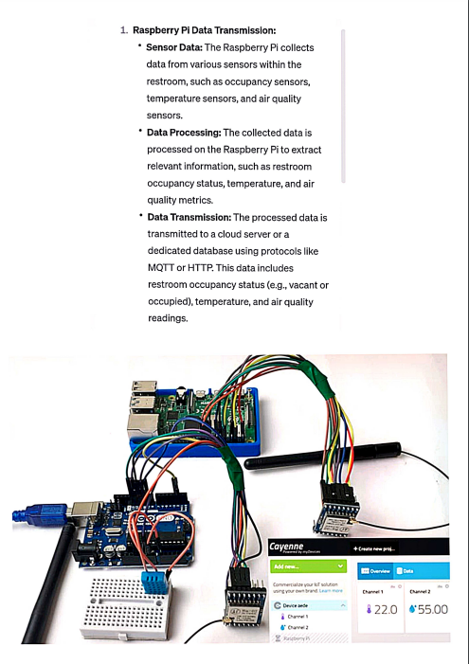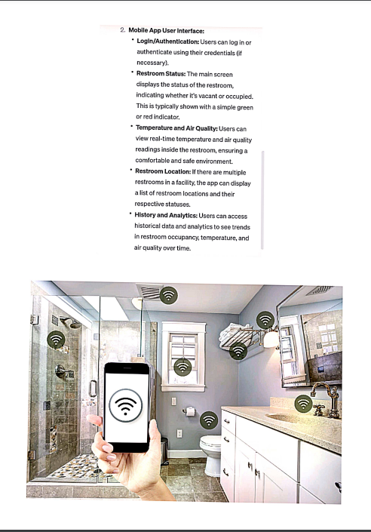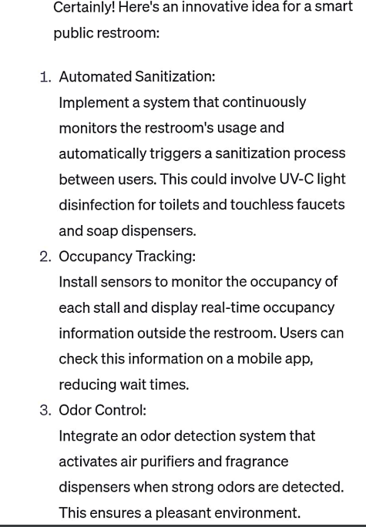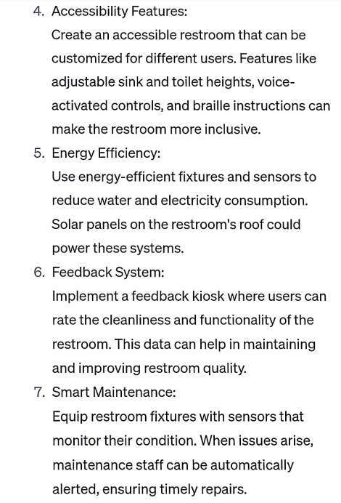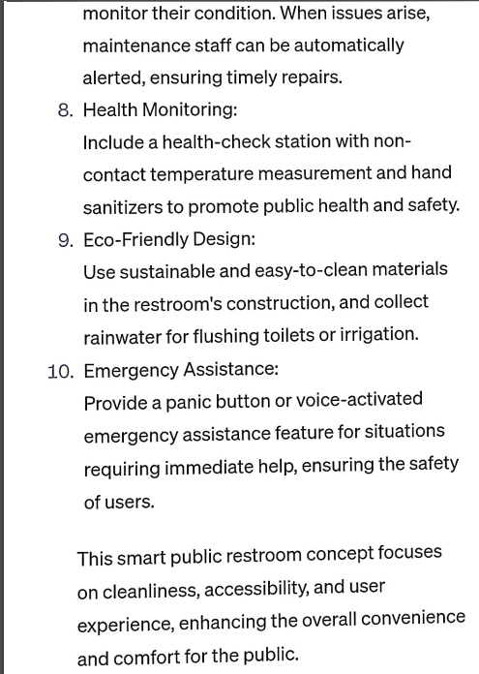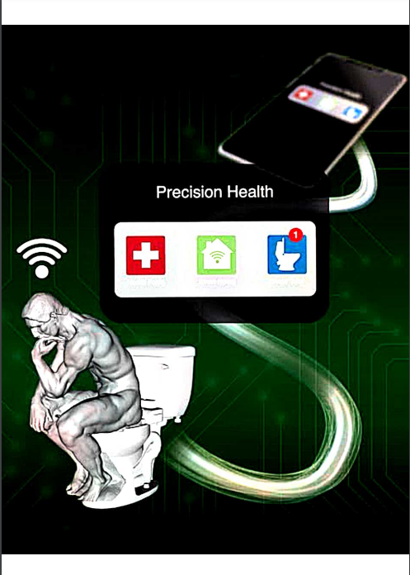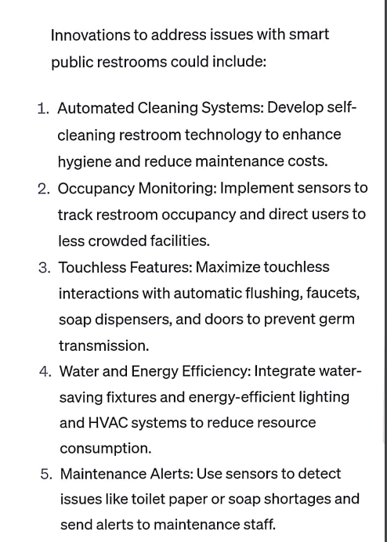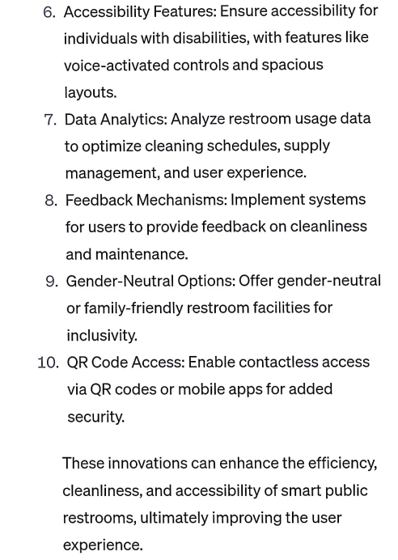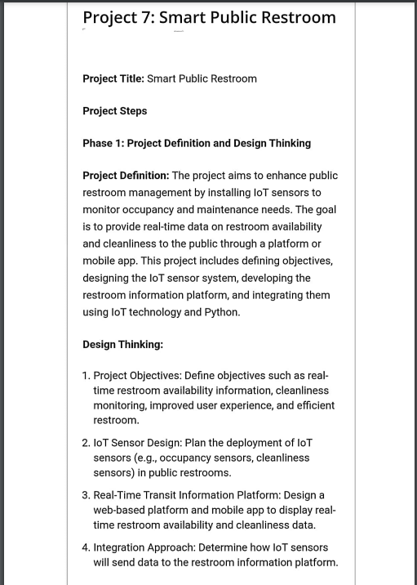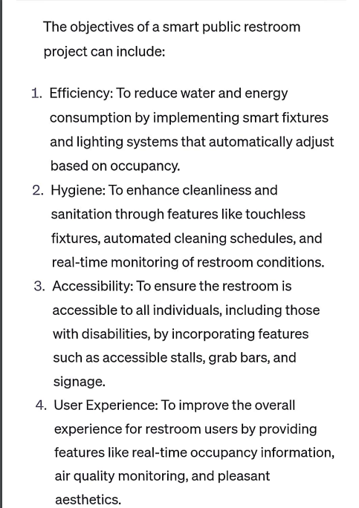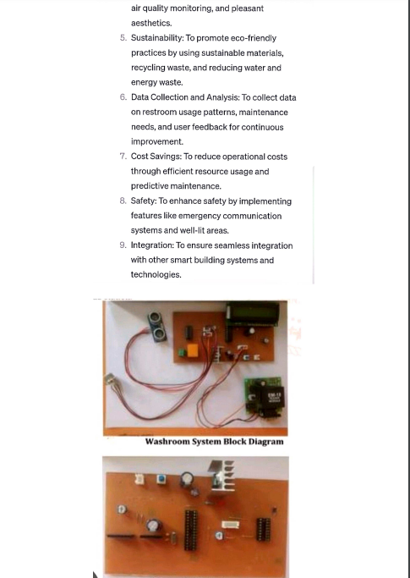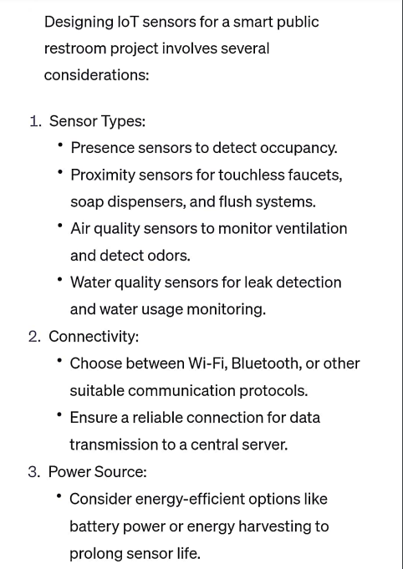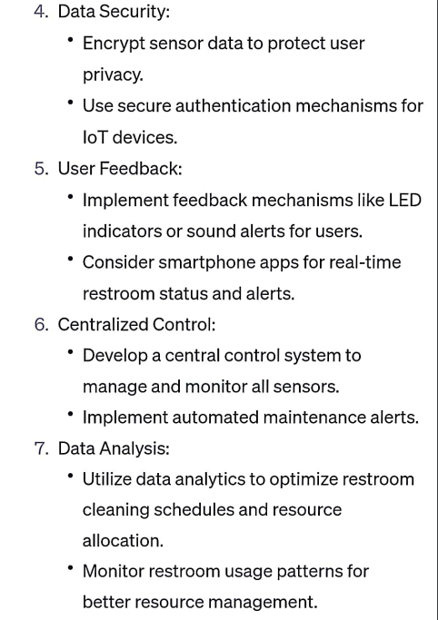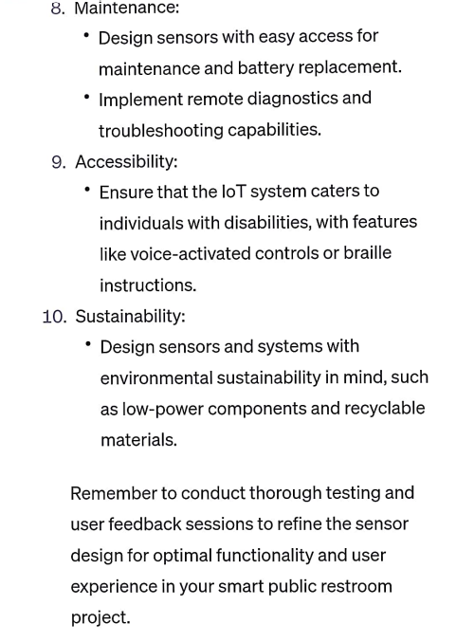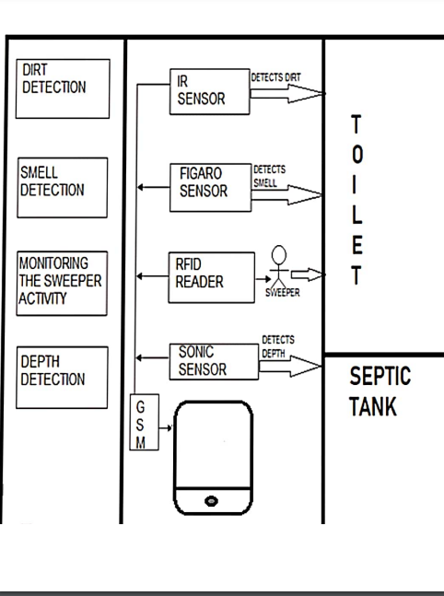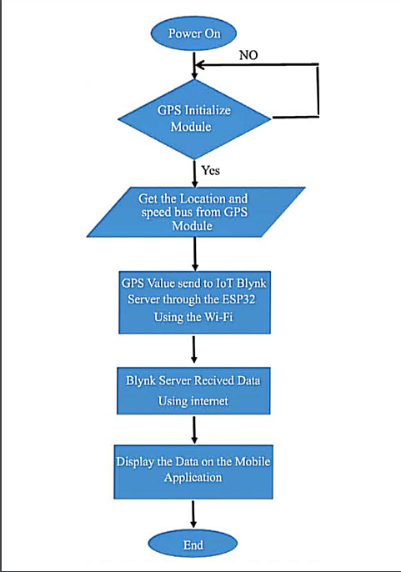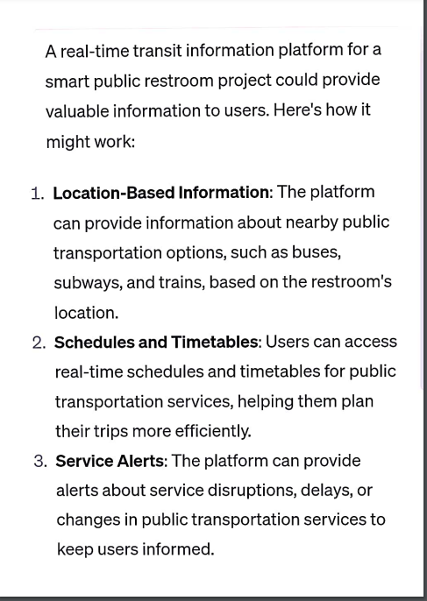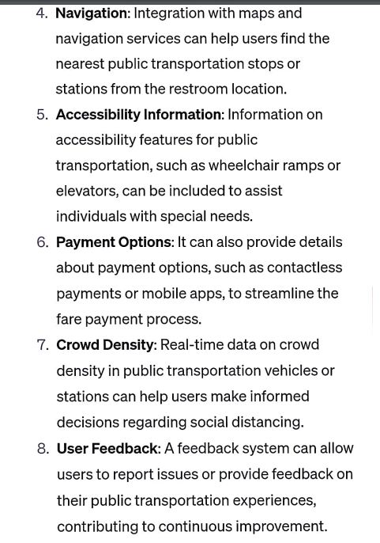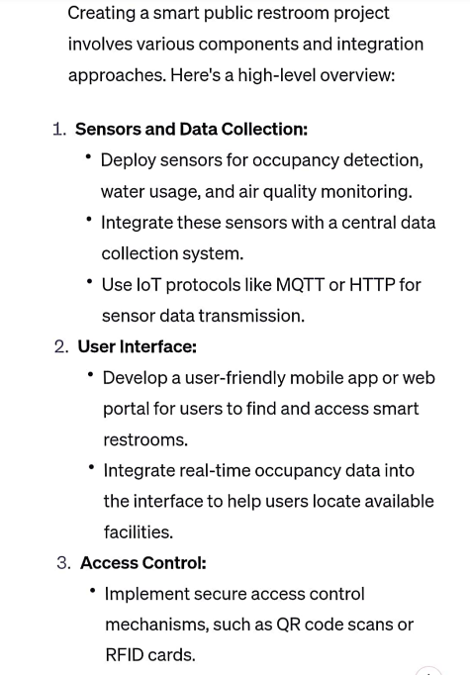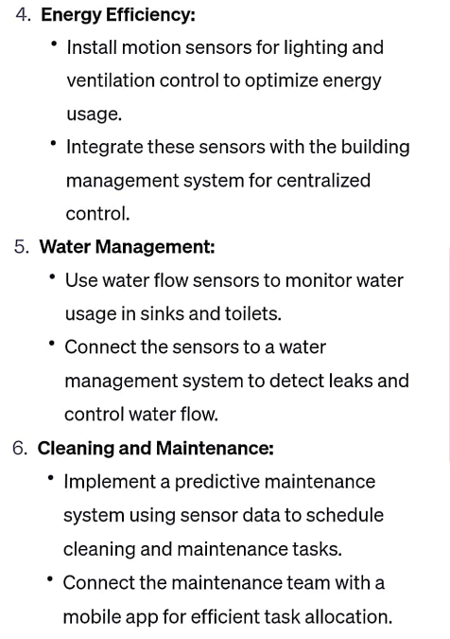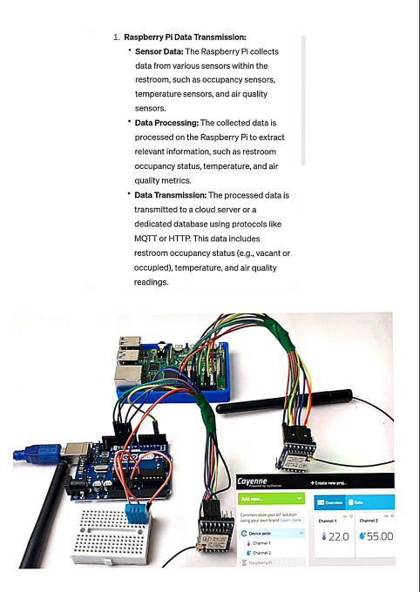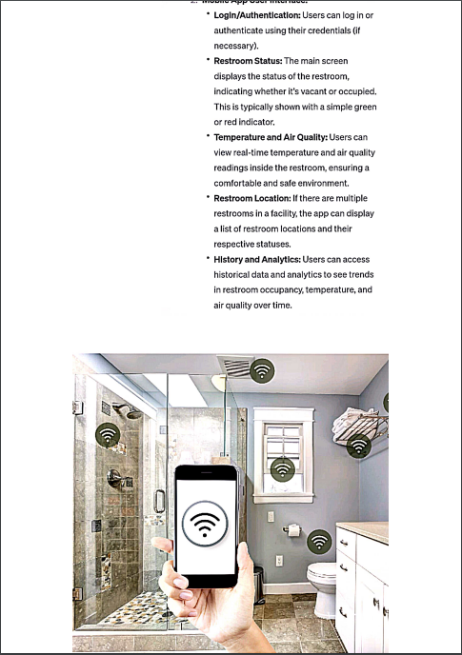

Phase 2:

Phase 3:

SMART PUBLIC RESTROOM   
DEVELOPMENT PART-1

Abstract — Public sanitation in many parts of India and slums is

sadly inadequate, with frequent urination and outflow due to

public toilets that may be very dirty or poorly maintained. Many

governments spend a lot of money and effort in keeping these

public toilets clean and tidy. All of these efforts to keep public

restrooms clean are in futile because there is no centralized

mechanism in place to monitor their cleanliness and cleaner

quality. In many regions of India and slums, public sanitation is

woefully inadequate, with rampant public urinating and

incontinence caused by overpopulation or poorly maintained

public toilets. Because of this issue, a system that allows

monitoring in one place of all public toilets and a cleaner

connection will be helpful in overcoming the problem of

pollution. The major goal of this project is to show how an

Internet of Things-based toilet monitoring system may be simple

to use. The web server and the mobile cleaner application are

used in this project. This technology allows the toilet cleaner and

the administrator to monitor multiple cleaning metrics and

inform the cleaner about the condition of the toilet based on user

input.

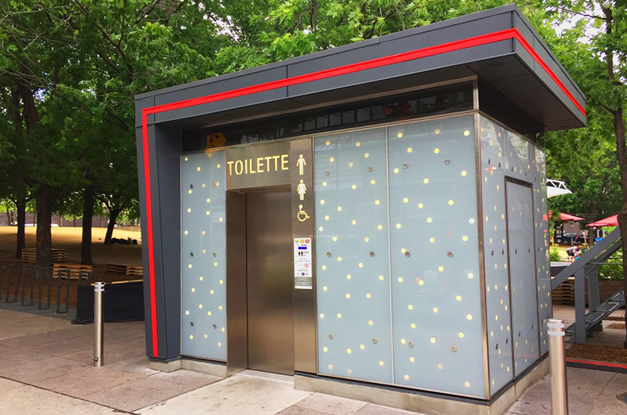

Despite the fact that our country has plenty of public

toilets, there is no other way to check and maintain their

cleanliness. There is no procedure in place to ensure that the

workers allocated to these restrooms are clean. Toilets should

be inspected in person to keep track of their state, which is harmful to employees. As a result of these causes, the quality

of public toilets has dropped dramatically, endangering the

health of the general public.

**The goal of this proposal is-**

to make it easier for people to maintain track of their health,

especially diabetes. The data acquired in this study will be

used to compare the data obtained in the urine of a diabetic

and a healthy person. Data pre-processing is a stage in which

data is separated into multiple categories. The information in

this study is presented in the form of numbers obtained from

the urine's RGB value. The k- means are used to process data

using the clustering approach. The steps below must be

followed in order to cluster using k-means.

In this research, we propose to use an IoT system to

collect data on many aspects of toilets to solve the problem of

toilet monitoring and maintenance, including air quality,

water availability, water closure, and vacant toilets. Using a

well-defined web interface, this software may provide

centralized data visualization. The system is sophisticated

enough to follow the cleaner's work and alert authorities if

they do not pay attention.

The authors suggest an IoT system to increase

restroom safety for the elderly and women. The system

employs sensors such as a leak detection sensor, a digital

nLight/Lux sensor, a voice detection sensor, and a pressure

sensor. This research examines the integration of a wireless

sensor local network system. The restroom is one of the most

dangerous locations, particularly for the elderly. Older

persons often have more difficulty with mobility and

balance, leaving them more vulnerable to restroom falls and

slips, as well as major health problems in the short and long

term. There is presently no IoT application for a bathroom.

Bathrooms, unlike other applications, have several distinct

characteristics, such as privacy and a wet environment. This

study proposes a holistic conceptual approach to the

development and deployment of an Internet-of-Things (IoT)

system to improve toilet safety. The idea is to employ a

major nursing care facility as a pilot testing bed for the

concept.

The sensor is utilised by placing it near the soap. The

cleaner is informed when the soap goes missing via the

mobile app. The Water Sensor is used to monitor the water

level in the tank that delivers water to the toilet. It is the most

appropriate sensor and the threshold status as well as an

action done for the same .A luminosity sensor detects the

brightness of the toilet and determines whether it is well lit

or not. The lights switch on automatically when the toilet's

brightness falls below the chosen threshold. The RFID

Scanner was chosen since it is ideal for this task. The RFID

Scanner is used to keep track of cleaners' attendance so they

don't forget to clean. Outside the toilet, there is an RFID

scanner. Every toilet has a rating system with rating buttons

where users may offer feedback after using the toilet so that

the toilets can be altered based on the feedback status. Using

the Node MCU, which allows them to connect to the internet

through Wi-Fi, all the sensors send data to the cloud every five minutes

. 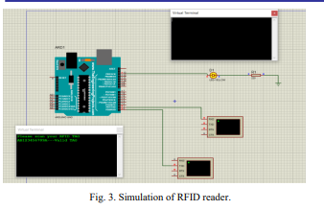

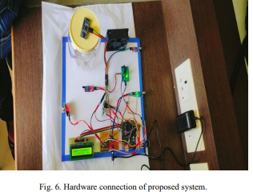

IoT Device to Monitor the Toilet:-

The MQ-135 sensor detects the stench of the toilet. The

presence of ammonia gas in the atmosphere is detected by

this sensor. The presence of Ammonia is responsible for the

toilet's foul odour. Ammonia has a pungent odour that can

only be perceived at a concentration of 5 parts per million

(parts per million).Fans automatically turn on when the

ammonia content in the toilet exceeds the set threshold of 5

ppm, while levels below 5 ppm have no impact. Moving on

to the next component, an infrared sensor is used to check

for the presence of soap in the toilet.

Data Processing is done over the cloud:-

To begin, data from IoT devices is pre-processed

depending on the sensor parameters' values. There might be

gaps in this data, as well as false measurements. Erroneous

readings are removed from the data, which is then

normalized and recorded with a timestamp in Thingspeak

database storage. This Thingspeak is a suitable choice for a

system that requires real-time data updates.

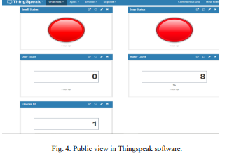

Thingspeak website where all the data

are stored. It shows Smell status, Soap status, user count,

water level, cleaner id. Soap and smell status is determined

using red light as shown in Fig. 4. If the soap is present in

the container then the red LED will turn on, similarly if there

is smell in the toilet then the red LED for smell status will

turn on. Water level is determined using percentages in water

level block. It also counts number of people entering the toilet in user count block.

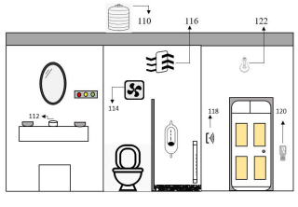

110- Water Tank.

120- Odour detection MQ-135.

112- Soap detector.

122- Automatic lights.

116- Ventilation fan 124- Frequency counter.

126- Cleaners attendance.

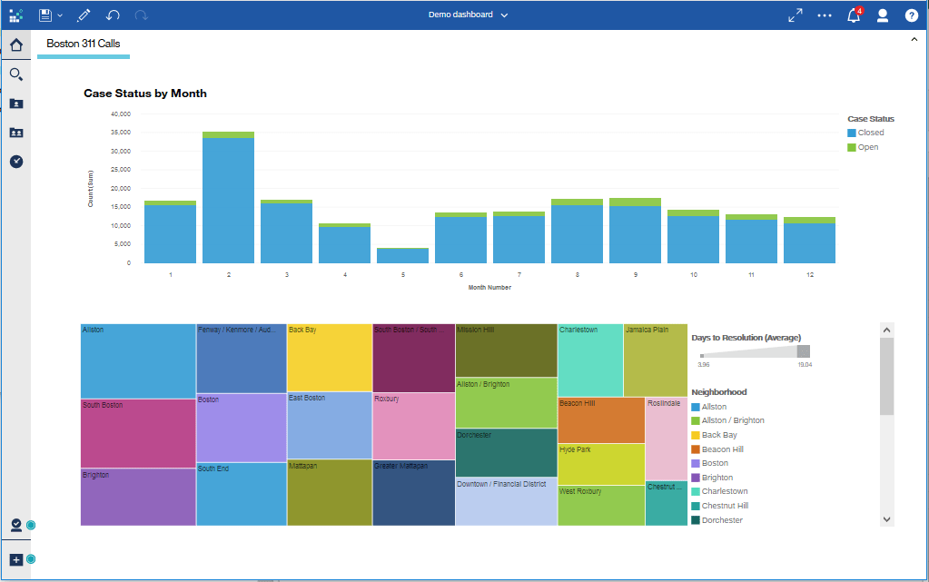

For water level detection we have used ultrasonic sensor

to measure the level of the water in the tank. In our hardware

we have used small container to store the water so based on

the distance, the ultrasonic sensor can detect the water level

which in turn displays the results on the LCD display as well

as in Thingspeak in percentage format.

Phase 4:

SMART PUBLIC RESTROOM  
DEVELOPMENT PART-2

**ABSTRACT:**

In the cutting edge world, the advances are definitely grown, yet at the same time the cleanliness in our nation is under risk. The abstract of this paper is to deliver clean and hygiene toilets. All the public toilets should be clean and hygiene. In our country, our government has introduced the scheme called “Swachh Bharat” (Clean India). Keeping the toilets uncontaminated is the one of the objective of Clean India scheme. This can be helpful to encourage the clean India project. In future, it can show the major part in clean India scheme. In an Existing system, they are focused only on identifying the dirt in the toilets. In our proposed system, we have determined on keeping clean toilets, observing the sweeper’s working activities. It can dodge many syndromes. It may create the consciousness amongst people about the toilet management. Therefore, our development is to use safe and hygienic toilets. This paper is based on IOT and image-processing concepts using different sensors like smell sensor, IR sensor, sonic sensor, RFID reader. By using these sensors, we can create the smart toilets.

**INTRODUCTION:**

In India it is estimated that on an average about 60% of the population have no toilets in their homes. The number is still higher in rural areas at about 72%. The condition of the limited number of existing public toilets being pathetic people prefer to defecate in the open thereby compromising themselves to dreadful diseases like cholera, typhoid, hepatitis, jaundice etc. It is estimated that there are above 25 lakh women in Delhi who go for their necessary functions before dawn every morning in the open fields putting their lives to risk in view of the high level of crimes against women. The Commission has always believed that adequate civic amenities help in enhancing the aesthetics of a city. In view of the unsatisfactory situation relating to public toilets in the city of Delhi, the Commission felt that it is high time that an initiative was taken for developing high tech self sustaining public toilets which could be put up in slums, unauthorized colonies, market places and in other places like gardens and parks where foot fall is high. After receiving approval from the Government in the year 2012 on a proposal mooted by it ,the Commission on the basis of a design competition developed a prototype for a low cost self sustaining High-Tech Public Toilets which has been installed at various locations around New Delhi.

**SCOPE OF THE PROJECT:**

In this we are going to provide the clean toilet. This paper can create the awareness among the people about the clean and hygienic toilets. This paper can ensure the responsibilities of the sweeper. Finally, this concept is the one of the stepping stone to the “Clean and disease free India”.

There are two part are involved here. They are,

1. Automatic Flusher Part (AFP)

2. Server part

In an existing system, they concentrate more on organizing sewages from the railway system. They are trying to taking all the medical tests through the usage of toilets. They are concentrated on reducing water wastage on toilets, by the implementation of automatic flusher.

**WORKING PRINCIPLE:**

• In the first phase, IR sensor is used to discover the dirt present in the toilet. • Here the set of sample images are given as input. • After using the toilet, the sensor senses the basin of the toilet. • Then it relates the sensed image with the input image. • If the dirt present, it increases the alarm. • Then the user wants to be clean the waste. Through this activity, people can get the awareness about the toilet management. • In the second phase, Figaro sensor is used to perceive the unwanted gases present in the toilet. • In the Figaro sensor, a particular range is to be stable earlier manner. If the range gets extended, it can send the alert message to the sweeper. Then they cleaned it by using proper fragrant. • In the third phase, RFID reader (Radio Frequency Identification) is used to observe the sweeper’s activities (absence and presence in the toilet cleaning). • Initially, the sweeper wants to show his/her individuality tag in front of RFID reader. It can be shown before and after cleaning the toilet. • Then the first phase gets initiated and senses for the dirt presence in the toilet. • If the dirt gets noticed, it raises the alarm. • Through this monitoring activity, the sweeper can realize their roles and responsibilities. Then they protect the people by disposing all the unwanted materials (dirt, unwanted gases) present in the toilet. • In the final phase, the sonic sensor is used to detect the depth of the septic tank. • Here, the range of septic tank is fixed prior manner. • If the sewage reached with the range, then it directs message to an organization. • All the message transfer can be done by the GSM (Global System for Communication).

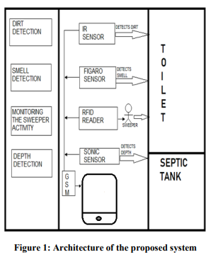

**DESCRIPTION OF ARCHITECTURE HARDWARE REQUIREMENTS:**

• Microcontroller

• Power supply

• LCD display

• Buzzer

• Infrared sensor

• Sonic sensor

• Gas sensor

• RFID

• GSM modem

**SOFTWARE REQUIREMENTS:**

• Embedded C.

MICROCONTROLLER:

A microcontroller is a small computer on a single combined circuit holding a processor core, memory and programmable input/output peripherals. Program memory in the form of Ferroelectric RAM, NOR flash or OTP ROM is also often included on chip, as well as a typically small amount of RAM. Microcontrollers are designed for embedded applications, in contrast to the microprocessors used in personal computers or other general-purpose applications.

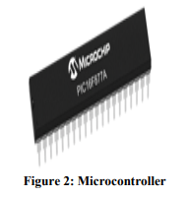

**BUZZER Buzzer:**

is also called as Beeper. It is a sound signaling mechanical device.

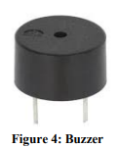

**INFRARED SENSOR:**

The IR sensor is used to detect the dirt present in the toilet. Here we nourish the image models into the sensor. It can perceive the dirt by comparing the images we feed into it, after using the toilet. If it can detect the dirt, it raises the alarm, and the users may get embraced and they clean it. This system can create the responsiveness among the people.

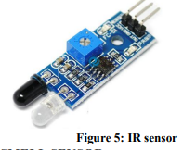

**SMELL SENSOR**

The Smell Sensor is used to detect the unwanted smell and gases in the toilet.

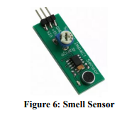

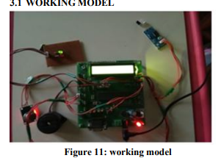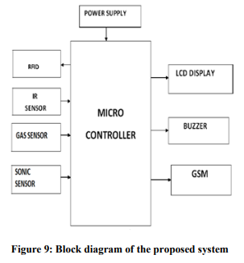

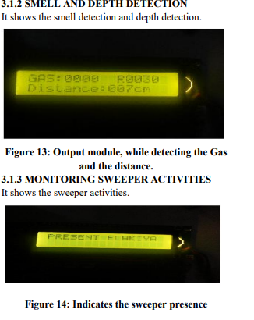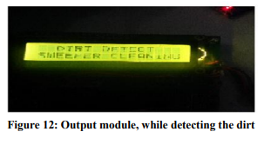

**ADVANTAGES :**

• It can creates an awareness among the people about the proper toilet management

• It can prevents the many contagious diseases like malaria, typhoid, cholera, streptococcus, asthma, etc..

• It can promotes the “Swachhbharat” scheme.

**CONCLUSION:**

Our proposed project will create awareness among the people about the proper sanitation. It makes use of Internet of things, which is a rapidly growing technology. Our proposed system will make everyone to strictly follow the cleanliness and proper sanitation in the toilets. It prevents the many new contagious diseases that spread due to improper sanitation of the toilets. Thus by using technologies in the smarter way, we can maintain the cleanliness which is next to the godliness. Keep Clean, Be Safe.

**SAMPLE DESIGN:**

(Size of the unit - 6.90m X 2.75m) (Internal height - 2.20m)

INTERNAL LAYOUT OPTIONS:

Option 01:

With Two Ladies WCs, One Universal Toilet as per CPWD specifications, three gents WCs, three urinals and three washbasins.

Combination of:

a. One universal

b. Two ladies WCs

c. Three gents WCs and four urinals

d. Three washbasins

